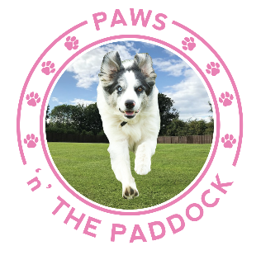

Dear Client
To safeguard the health and welfare of all our valued clients, we must refuse entry to the dogs of any persons who are unwell, who have been to locations of public health concern in the past 14 days or who have been in contact with any person with a confirmed case of the coronavirus.
In order to comply with this, please answer the following questions -
1. Have you been in contact with any person who is a confirmed case of COVID-19 in the past 14 days? YES/NO
2. Do you currently have a fever or any flu-like symptoms such as persistent cough, high temperature, loss of smell/taste? YES/NO
3. Please confirm that you have not travelled to the United Kingdom from any of the countries or regions listed on the GOV.UK website YES/NO
Please notify Marisa as soon as possible if your situation changes, and she will do likewise.

Signed:………………………………………………

Print:…………………………………………………

Date:…………………………………………………

Wishing us all a speedy end to the current situation and please stay safe and well in the meantime, Marisa and the Paws n The Paddock gang xxx
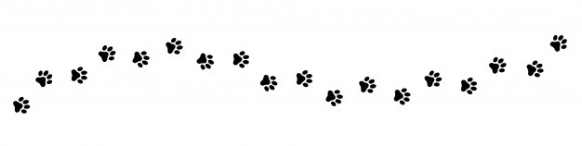

Please bring this form with you to your next session or email to marisathepaddock@outlook.com

